Problem 1

a.

 - 1st for loop

- 2nd for loop

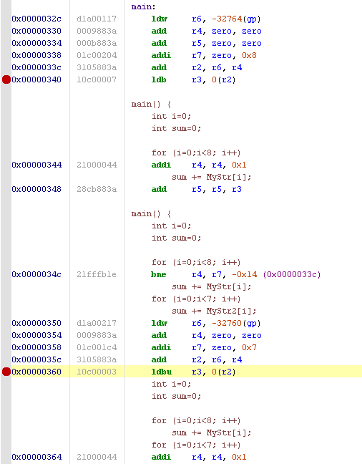

b. 1st array 8 bytes 2nd array 7bytes

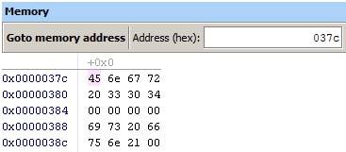

c.

The main difference I noticed was the lack of a defined loop structure in version 06. All the values seemed to be loaded into registers and summed up without the use of the loop employed in version 02.

